EXPERIMENT 3A – DATA CLEANING AND DATA TRANSFORMATION

Aim
To clean and transform the employee dataset by identifying and handling missing values, removing duplicate records, detecting outliers using the IQR method, normalizing the salary values using Min-Max normalization, encoding the categorical department values, and displaying the transformed dataset.

Algorithm
Step 1: Import the Pandas and NumPy libraries.
Step 2: Load the employee dataset from the specified CSV file using pd.read_csv().
Step 3: Display the employee dataset.
Step 4: Check for missing values in the dataset using df.isnull().
Step 5: Calculate the total number of missing values in each column using df.isnull().sum().
Step 6: Replace missing values in the Age column with the mean age.
Step 7: Replace missing values in the Salary column with the mean salary.
Step 8: Identify duplicate records using df.duplicated().
Step 9: Remove duplicate records using df.drop_duplicates().
Step 10: Calculate the first quartile (Q1), third quartile (Q3), and Interquartile Range (IQR) of the Salary column.
Step 11: Determine the lower and upper limits for detecting salary outliers.
Step 12: Identify salary values that fall outside the lower and upper limits.
Step 13: Normalize the Salary column using Min-Max normalization with MinMaxScaler.
Step 14: Encode the categorical Department column into numerical values using LabelEncoder.
Step 15: Display the final cleaned and transformed dataset.

Program
import pandas as pd
import numpy as np

# Load the dataset
df = pd.read_csv(r"C:\Users\palan\OneDrive\Documents\employee.csv")

# Display the dataset
print(df)

# Check for missing values
print(df.isnull())

# Count missing values
print(df.isnull().sum())

# Handle missing values using mean
df["Age"] = df["Age"].fillna(df["Age"].mean())
df["Salary"] = df["Salary"].fillna(df["Salary"].mean())

print(df)

# Check duplicate records
print(df.duplicated())

# Remove duplicate records
df.drop_duplicates(inplace=True)

print(df)

# Detect salary outliers using IQR
Q1 = df["Salary"].quantile(0.25)
Q3 = df["Salary"].quantile(0.75)

IQR = Q3 - Q1

lower = Q1 - 1.5 * IQR
upper = Q3 + 1.5 * IQR

outliers = df[
(df["Salary"] < lower) |
(df["Salary"] > upper)
]

print(outliers)

# Normalize Salary using Min-Max Scaling
from sklearn.preprocessing import MinMaxScaler

scaler = MinMaxScaler()

df[["Salary"]] = scaler.fit_transform(df[["Salary"]])

print(df[["Salary"]])

# Encode Department
from sklearn.preprocessing import LabelEncoder

encoder = LabelEncoder()

df["Department"] = encoder.fit_transform(df["Department"])

# Display final dataset
print(df)

OUTPUT
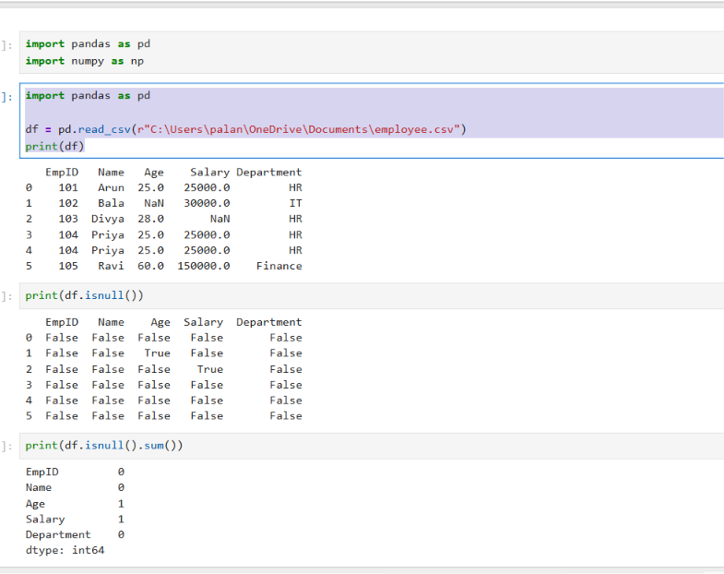

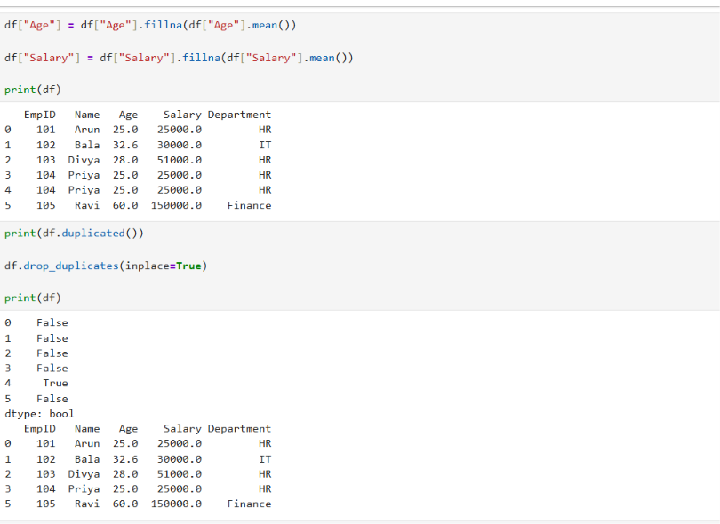
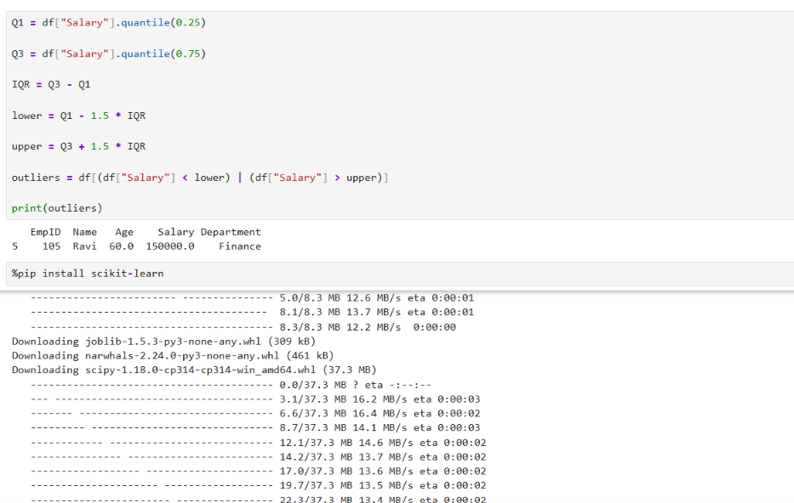

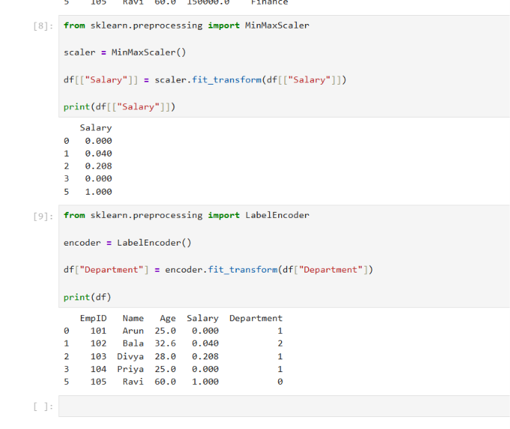

Result
The employee dataset was successfully cleaned and transformed. Missing values in the Age and Salary columns were replaced using the mean values, duplicate records were removed, and salary outliers were identified using the IQR method. The Salary column was normalized using Min-Max scaling, and the categorical Department column was converted into numerical values using Label Encoding. Thus, the dataset was successfully prepared for further data analysis and machine learning applications.

